Improving XML Visualization Without Cross-Origin Issues

1. Introduction
2. The Cross-Origin Restriction Problem
2.1 What Is Cross-Origin Access?
2.2 Symptom
3. Existing Workaround (Local HTTP Server)
4. Solution Options
4.1 Embedding the XSL Directly into the XML
4.2 Generating a Self‑Contained HTML Report
5. References

nt : Context and additional notes on pages 78, 97 and 98 of Notebook 2 - Sept 2024

Introduction
In many data processing and analysis pipelines, XML (eXtensible Markup Language) is used for structured data representation, often accompanied by an XSL (eXtensible Stylesheet Language) file to define its visual layout. While this approach works well in controlled environments, it presents usability issues in modern web browsers due to cross-origin restrictions.
This report explores methods to resolve this limitation while maximizing usability for non-technical end users.

2. The Cross-Origin Restriction Problem

2.1 What Is Cross-Origin Access?
Modern browsers implement strict Cross-Origin Resource Sharing (CORS) policies to protect users from potential security vulnerabilities. Under these policies, a file loaded using the file:// protocol is considered a separate security origin. As a result, XML files referencing external XSL files via relative paths cannot load stylesheets when opened directly from the local file system
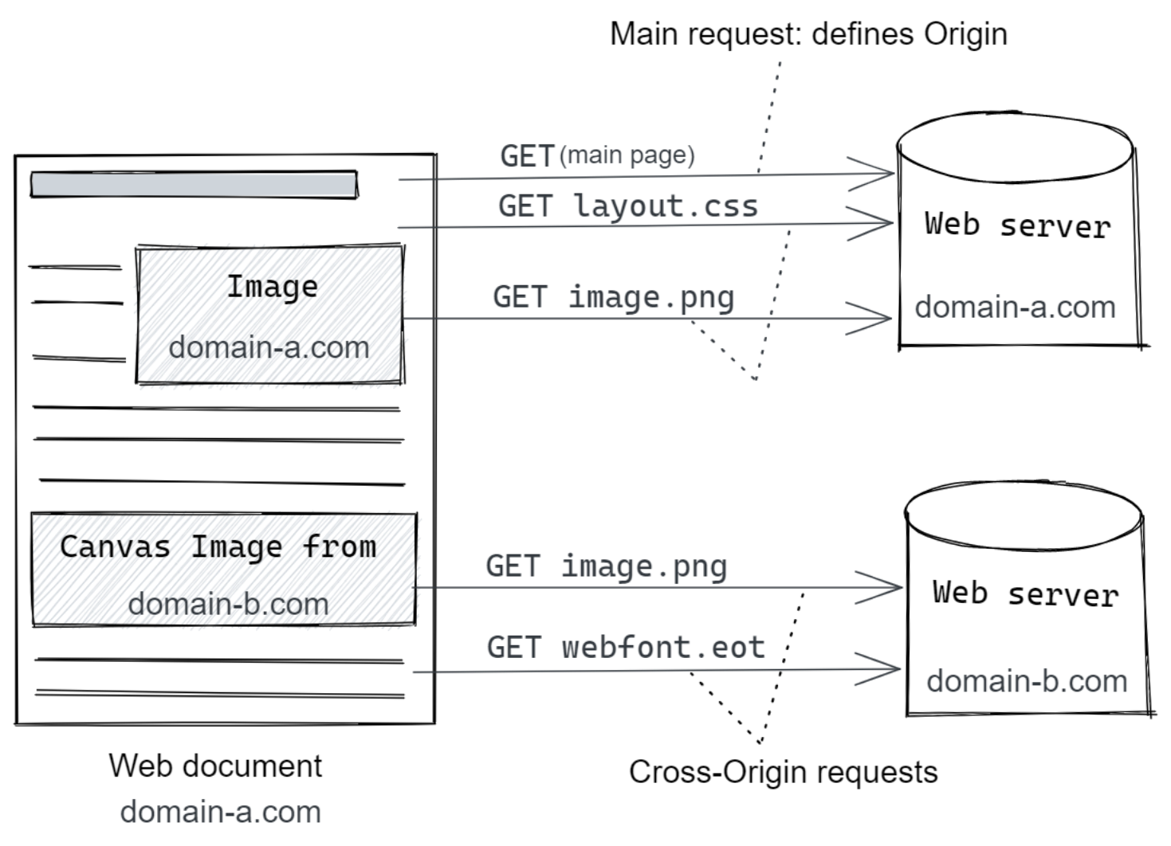
Figure 1: Cross Origin Access example

2.2 Symptom
When opening an XML file like Pablo_20250410_0_GA.xml directly in a browser, users encounter a blank page. The browser's Developer Tools report the following:
Unsafe attempt to load URL file:///.../Style/general_analysis.xsl from frame with URL file:///.../Pablo_20250410_0_GA.xml. 'file:' URLs are treated as unique security origins.

3. Existing Workaround (Local HTTP Server)
A common workaround is to serve the XML and its dependencies using a local HTTP server:
This resolves the issue since all files are served under a single HTTP origin, bypassing browser restrictions. Not suitable for end users: Requiring users to install Python and run terminal commands is not practical for non-technical audiences.
cd C:\Users\pablo\Documents\InputLog\Pablo\2025-04-10_0\output
python -m http.server 8000
http://localhost:8000/Pablo_20250410_0_GA.xml
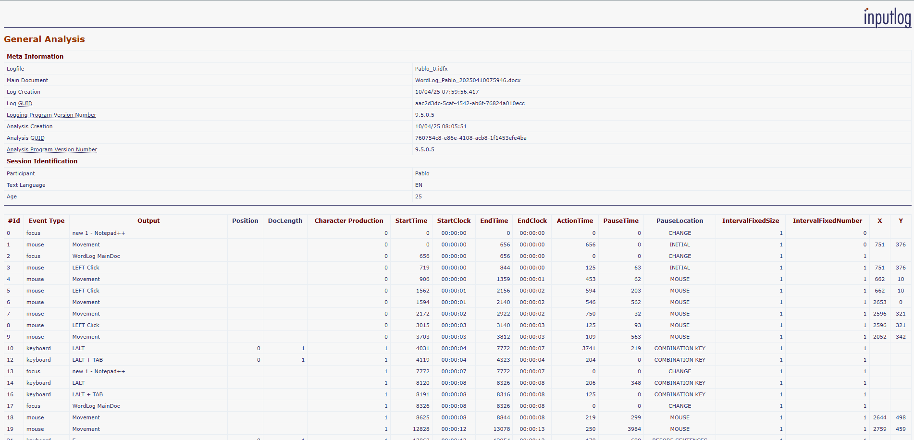
Figure 2: Example of Cross Origin Validation workaround

4. Solution Options

4.1 Embedding the XSL Directly into the XML
Embedding an <xsl:stylesheet> block within the XML and referencing it via href="#stylesheet" creates a single, self‑contained file that users can open by double‑clicking, with no external dependencies or internet required.
While this approach ensures portability and eliminates cross‑origin restrictions, it increases file size, duplicates the stylesheet across multiple documents, and complicates maintenance since any style changes must be propagated into each XML file. This injection can be automated in the generation script.

4.2 Generating a Self‑Contained HTML Report
An HTML report can be created by transforming the XML file (via XSLT), delivering a browser‑friendly document that supports rich formatting, images, and interactive elements.
Figure 3: Example of self-contained HTML report

4.3 Solution Approach
In this release, we adopted the second strategy—implementing a dedicated XML‑to‑HTML translation stage—detailed in section 4.2. The core change is the introduction of the XmlToHtmlTranslator class under the Core.IO.Html namespace. This component ingests the XML outputs previously written to output/, wraps their contents in a standardized HTML template, and emits the result as .html files in the same folder. After translation, the original XML files are relocated into a new Xml/ directory to preserve them for auditing or alternative workflows.
Directly targeting the Xml/ folder during XML generation was considered but deemed too risky: existing writer components (e.g., GeneralAnalysisXmlWriter) share a unified DestinationPath provided by AnalyzeMode.cs, which lacks a dedicated XML subpath. Refactoring all writers to support separate paths would require extensive changes across the codebase and introduce potential regression points. Moving files post‑generation isolates risk and preserves the current architecture.
Each translation run locates the appropriate XML file by matching its base name against a configurable mapping. The translator uses a regular expression to identify the file key within the cleaned filename:
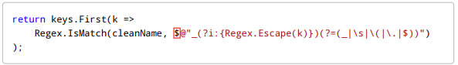
This mechanism supports successive output filenames (e.g., General_Analysis(1).xml) without requiring manual updates. However, if analysis types or file naming conventions change, the mapping dictionary below must be updated accordingly:
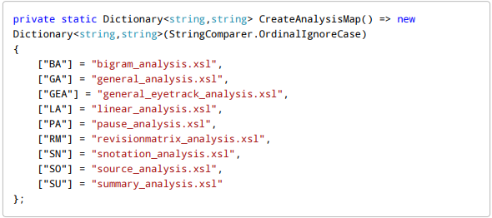

All methods and logic within XmlToHtmlTranslator are comprehensively documented in‑line, enabling developers to understand and extend the functionality without referring to external documentation.
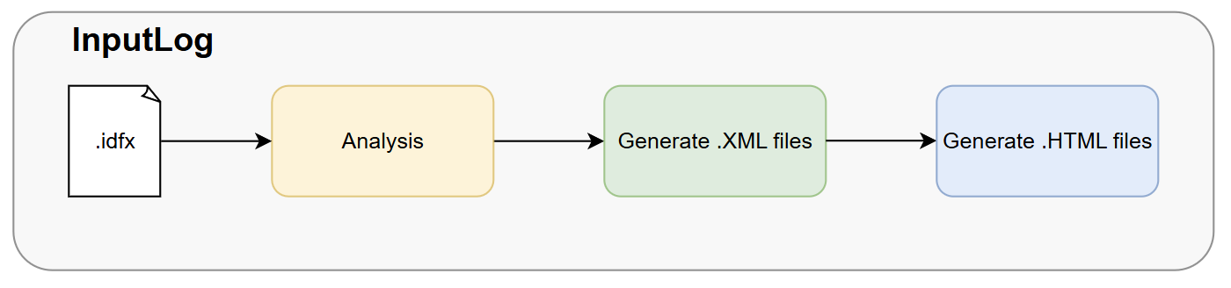
Figure 5: Process Overview
We appended the translation step at the end of the existing pipeline, ensuring no modifications to upstream analysis or XML‑writing components. This non‑intrusive integration preserves stability while delivering HTML outputs alongside legacy XML.

5. References
[1] Mozilla Developer Network.CORS Overview
[2] JavaScript.info. Fetch and Cross-Origin Requests
[3] Mozilla Developer Network.XSLT: Extensible Stylesheet Language Transformations

